PSC Project – Feedback Processor (Pulpy Juices)

Roll no -

21bce238

21bce239

21bce246

System Requirement -

1. Django
2. Matplotlib

Steps to run our program -

1. Download the zip folder and extract it.
2. Open that folder in vs code.
3. In the terminal type the command - "python manage.py runserver".

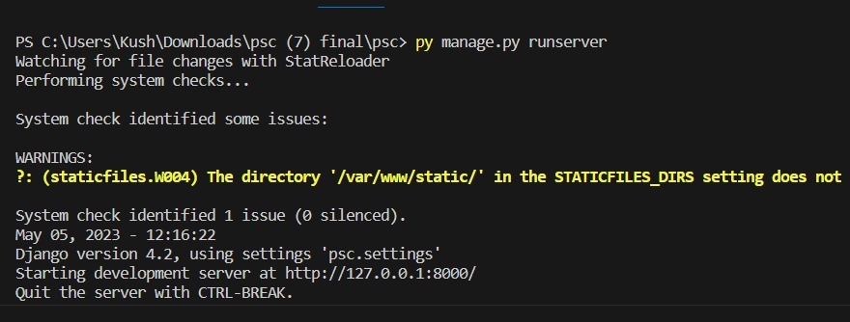

1. You will get a link like - "http://127.0.0.1:8000/ " in the terminal.
2. Open that link in the browser and our project is ready to view.

List of Username and their Role (for login) –

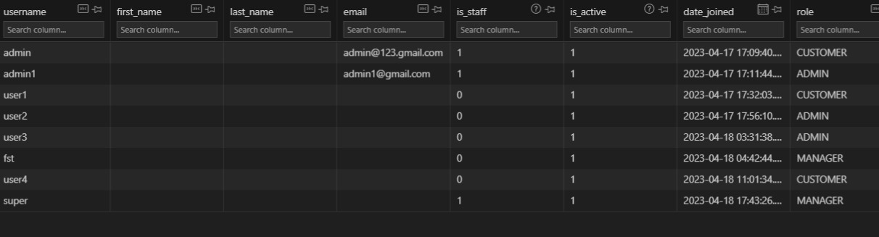

Password and username are same